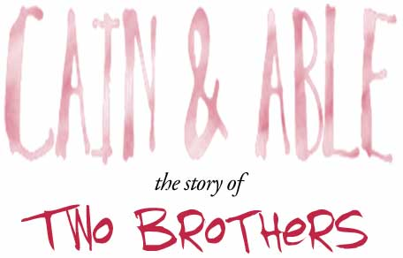
(Genesis 4.1-16)

Now they were going to have to work hard for their food and their clothes. And because of their sin, so would everyone who ever lives. God loves us more than we will ever know, and his blessings are always with us. But there will always be trouble in our lives too, sometimes little, and sometimes big - because sin is in the world now.
Sin always brings trouble. But even though Adam and Eve had sinned, God still loved them us as much as he ever did. And soon he blessed them with a baby - the first baby ever born! That must have been exciting. Of course, there wasn't a hospital to go to. And there weren't any doctors or nurses around (because they hadn't been born yet!). So God must have helped them.
They named their first baby Cain. And after that they had another baby, Cain's little brother, and they named him Abel. They had other children after Cain and Abel too, and their children had children, and their children's children had children. And that is how the world began to be filled with people. When Cain got older he became a farmer. He grew things from the ground. And when Abel grew up he became a shepherd. He took care of the sheep.
So it happened one day that Cain and Abel brought gifts to God to thank him for all the good things he had done for them. They built an altar for a sacrifice. A sacrifice is when you give something to God that you would have liked to keep for yourself. You give him your very best.
Cain brought some of the things he had grown. He brought some wheat, and grapes and figs and things like that, and he burned them on the altar to give to God. Abel brought the first lamb born to one of his sheep. God was happy with Abel's gift, because he saw that Abel really wanted to please God and always do what God wanted. But God knew that Cain wasn't so sure he wanted to do what God wanted. So God wasn't happy with Cain's gift.
That made Cain mad. God loved Cain, and he said to him, "Why are you scowling? If you always do what is right, you will be happy. But be careful. Bad thoughts will ruin your life. Learn to control them."
But Cain didn't listen to God. Instead he blamed his brother.
And even though God loved both brothers as much as anyone could ever be loved, Cain thought God loved Abel more than him. So from that day on, Cain began to think mean things about his younger brother. He kept thinking them and thinking them. And the more he thought them, the harder it was to stop. And the more he thought them, the meaner his thoughts became. Until one day he planned a terrible thing.
He said to his brother on a bright, sunny morning, "Abel, come with me out into the fields." "Sure," Abel said, because he loved his big brother, and trusted him. And so he walked with his brother out into the fields. And when Cain got Abel out where nobody could see or hear them, he took a rock and he killed his brother Abel. Later that day God found Cain working in the hot sun. God said to him, "Where is your brother Abel?" "How should I know?" Cain said. "Am I supposed to take care of my brother?"
But God knew the terrible thing Cain had done. God said to him, "I see your brother's blood on the ground! Because you have spilled your brother's blood into the ground, the ground won't grow your crops for you anymore. From now on you will have to wander in far away places to find your food." "Lord, the punishment is too hard for me!" Cain said. "My relatives will try to kill me when they hear what I have done. I will always be running." So God put a mark on Cain to protect him. When anyone saw it they would know not to kill him because God was watching.
Then on a sad, sad day, Cain left his only home and family. Because of the evil thing Cain had done, Adam and Eve lost not just one son, but two. And Cain lost his family. But worse than that, God would not be with him anymore. That would be the hardest thing of all. So Cain went away and lived in the land of Nod. If only he had listened to God.

